Unboxing the OT-One



Written by Opentrons

Updated this week

# This article is about the OT-One.

## **It's no-longer sold or actively supported by Opentrons, but we've kept this article here to help existing users. Please** [**see our OT-2 Support articles**](https://support.opentrons.com/) **for the most up to date information!**

# Welcome to the Opentrons family!

Here is a step by step video on how to set up your OT-One

You can also use the instructions below:

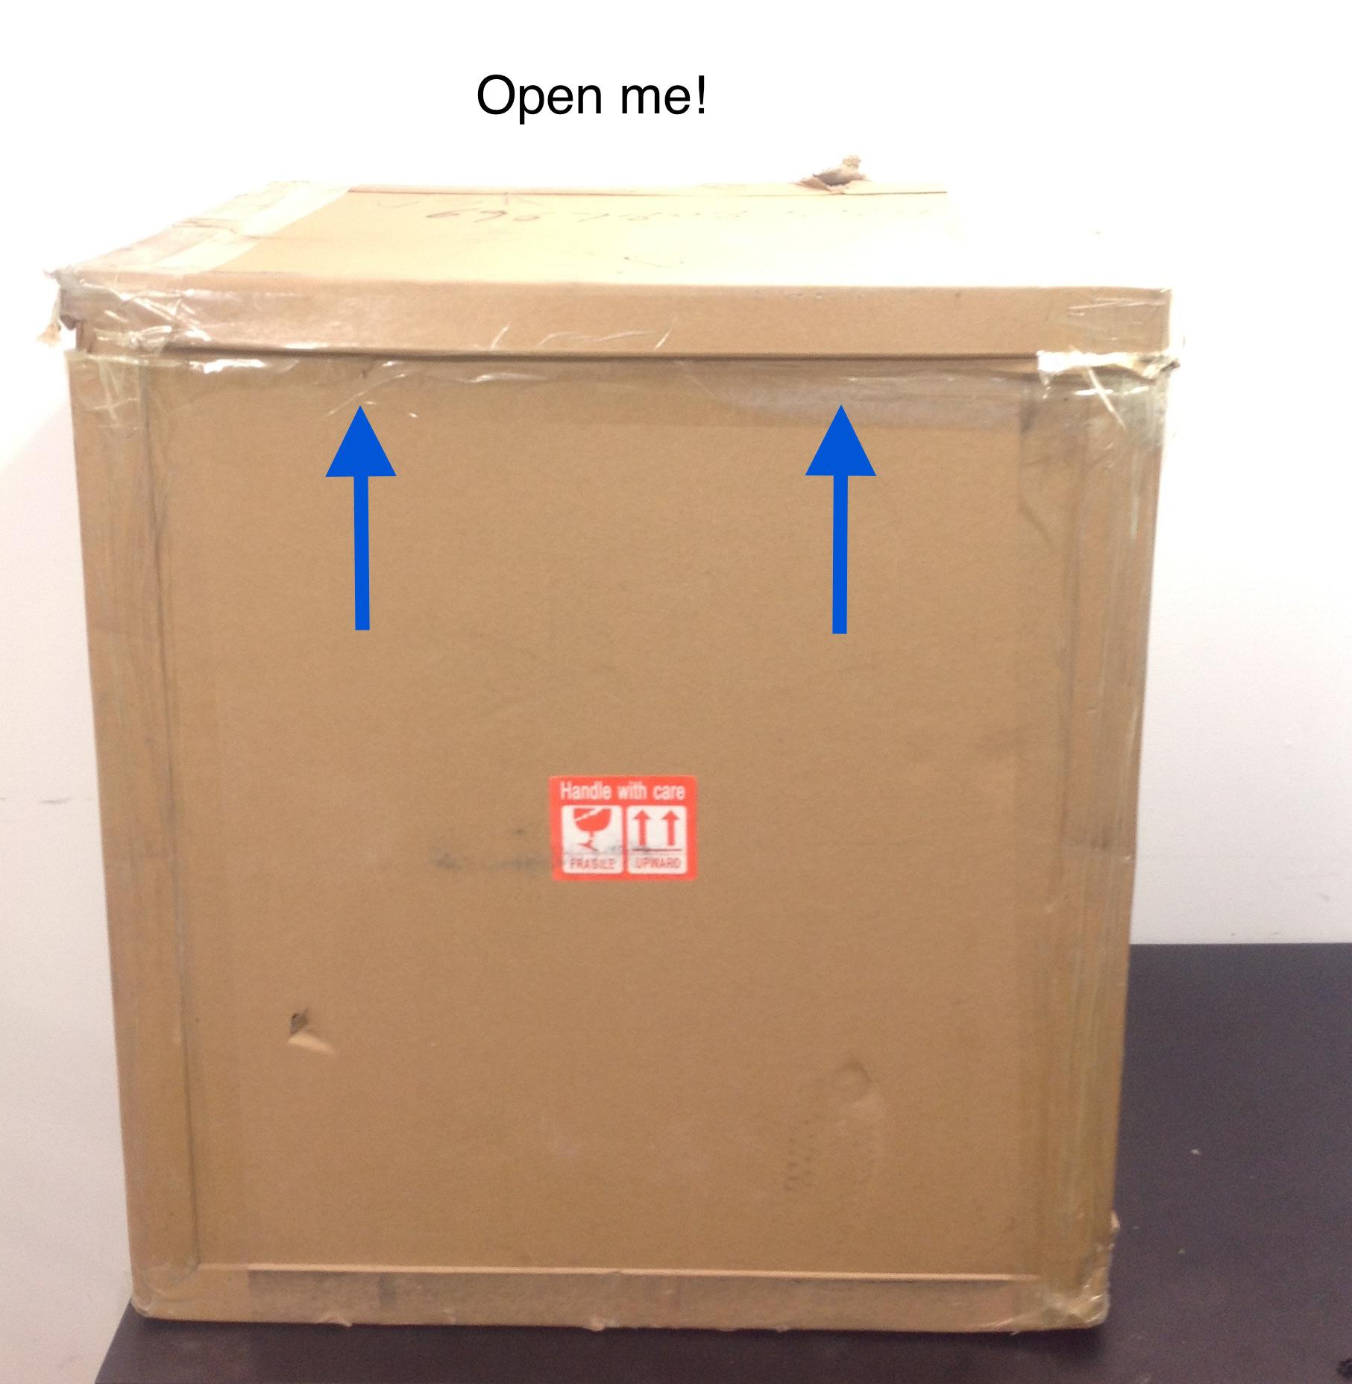

*You will need a pair of scissors to cut the tape along the top lid of the box.*

________________________________________________________

Remove the top layer of foam

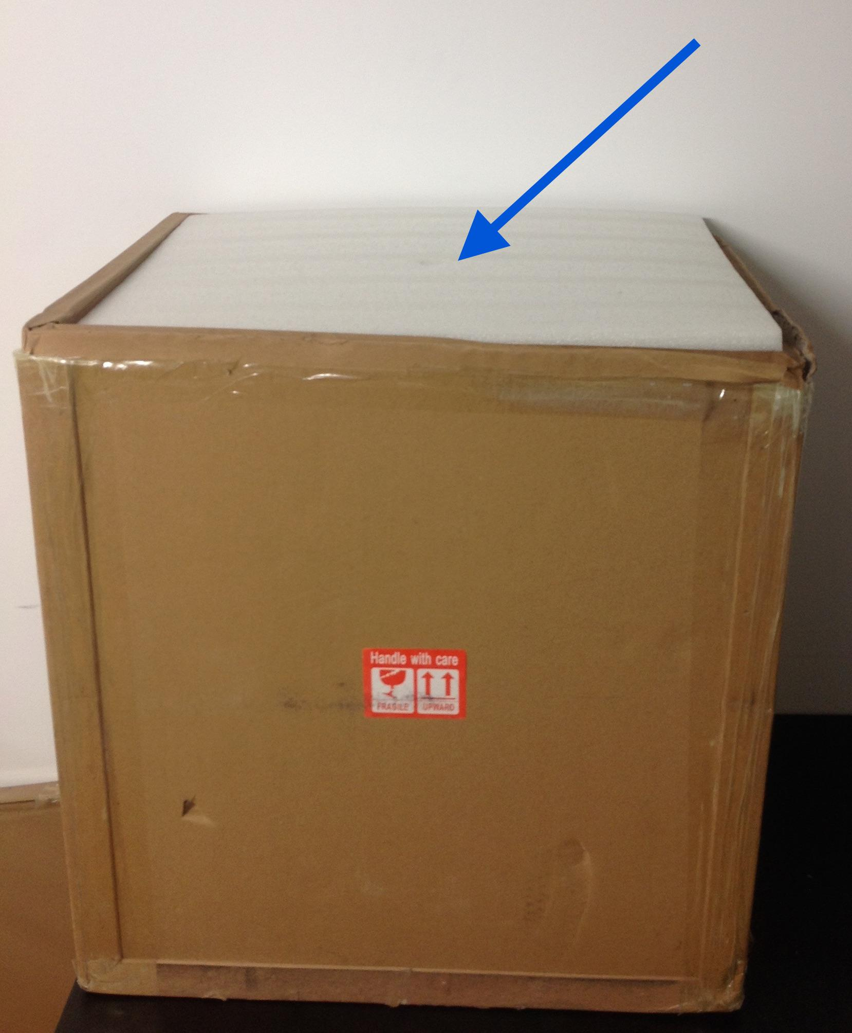

_______________________________________________________

Cut the Zip tie securing the bag enclosure

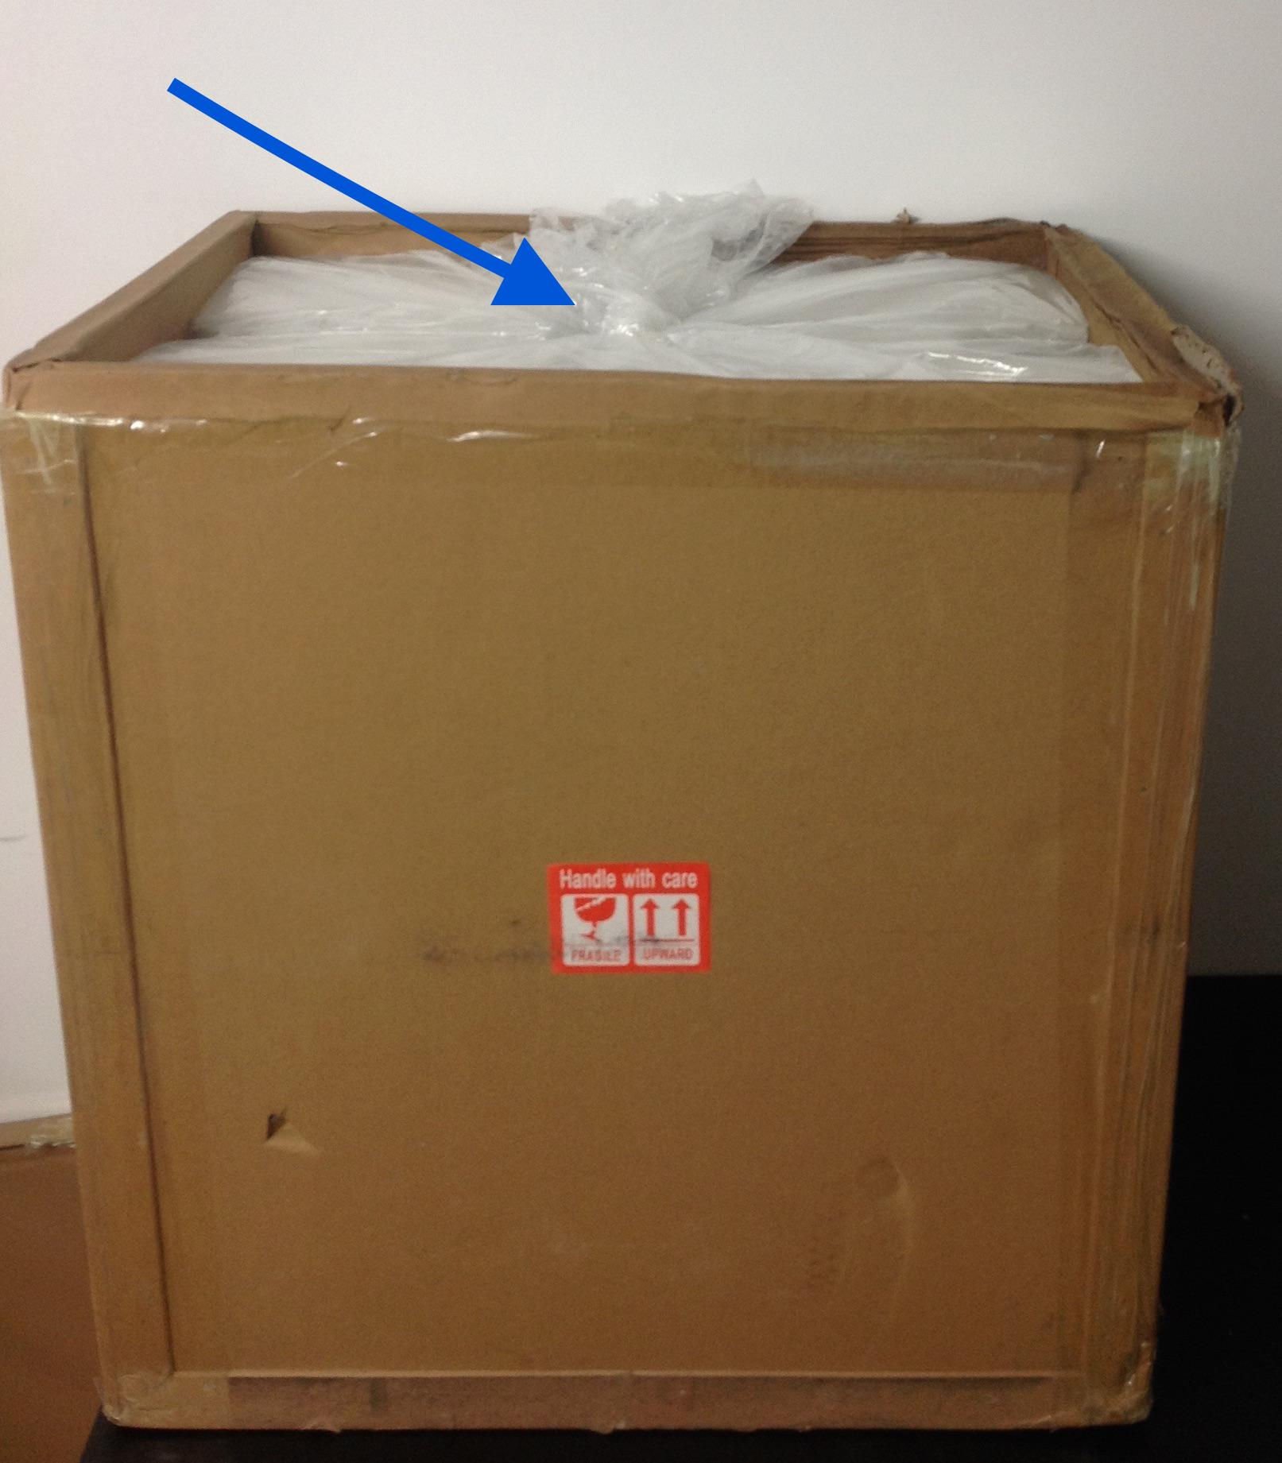

________________________________________________________

Remove the large piece of foam

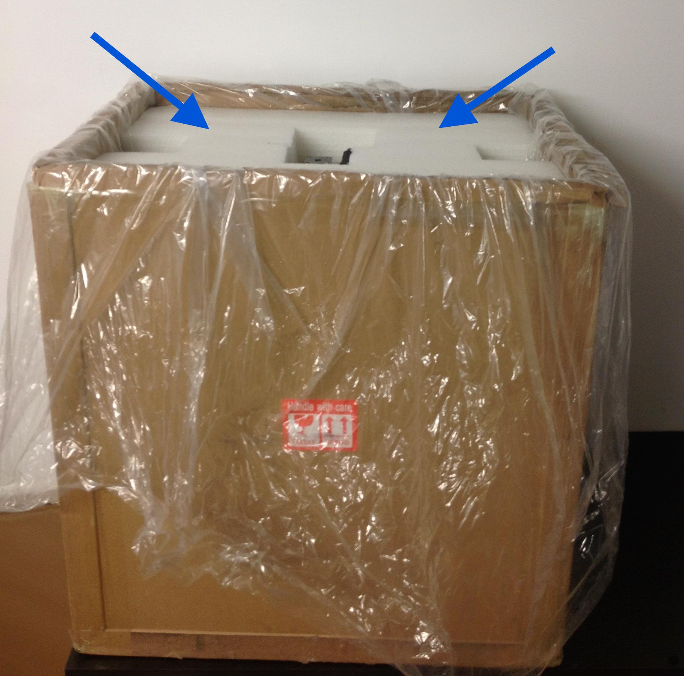

________________________________________________________

Time to take your robot out of the box! Lift robot by Y axis bars.

*\*\*Pro tip: Grab a labmate for assistance, the OT-One is approximately 20kg!*

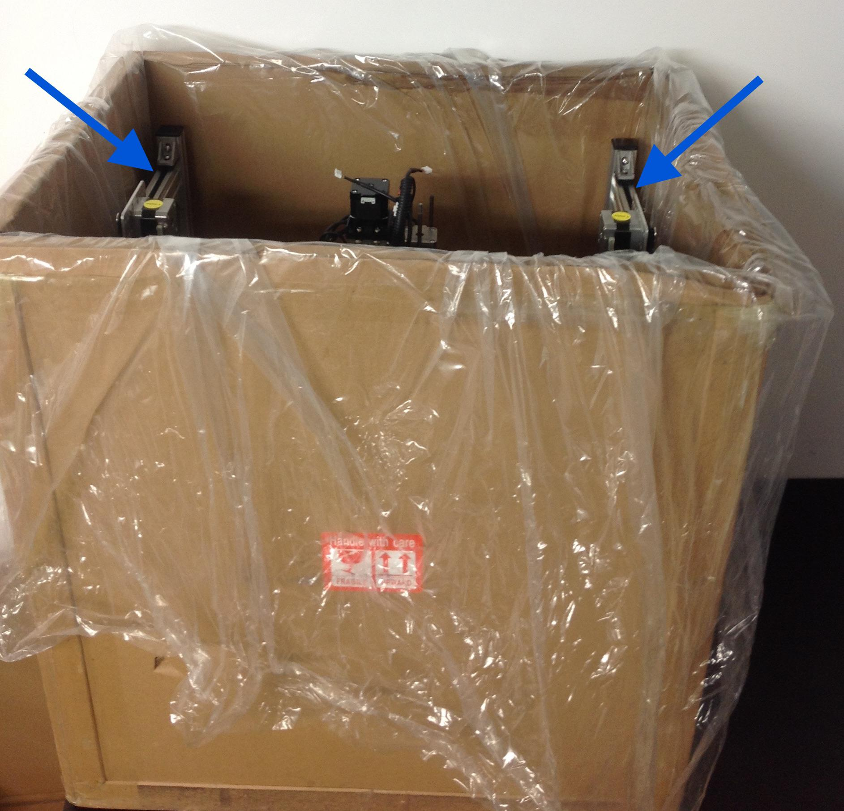

________________________________________________________

Place the robot on your lab bench

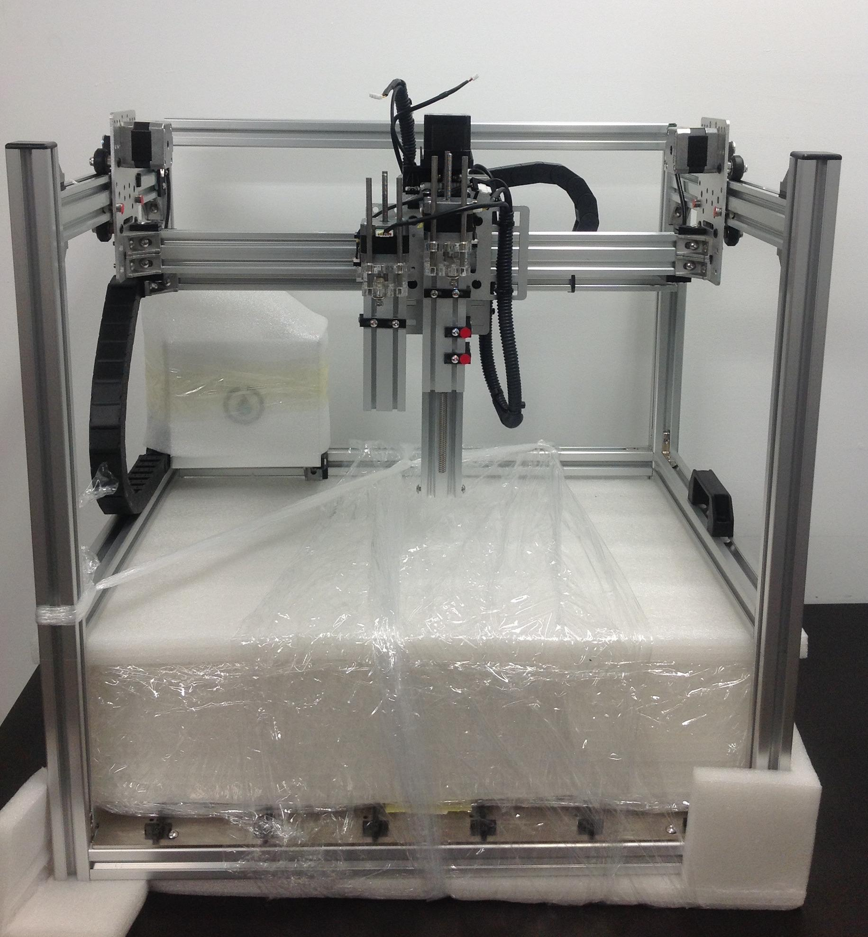

________________________________________________________

Cut plastic wrap securing the accessories.

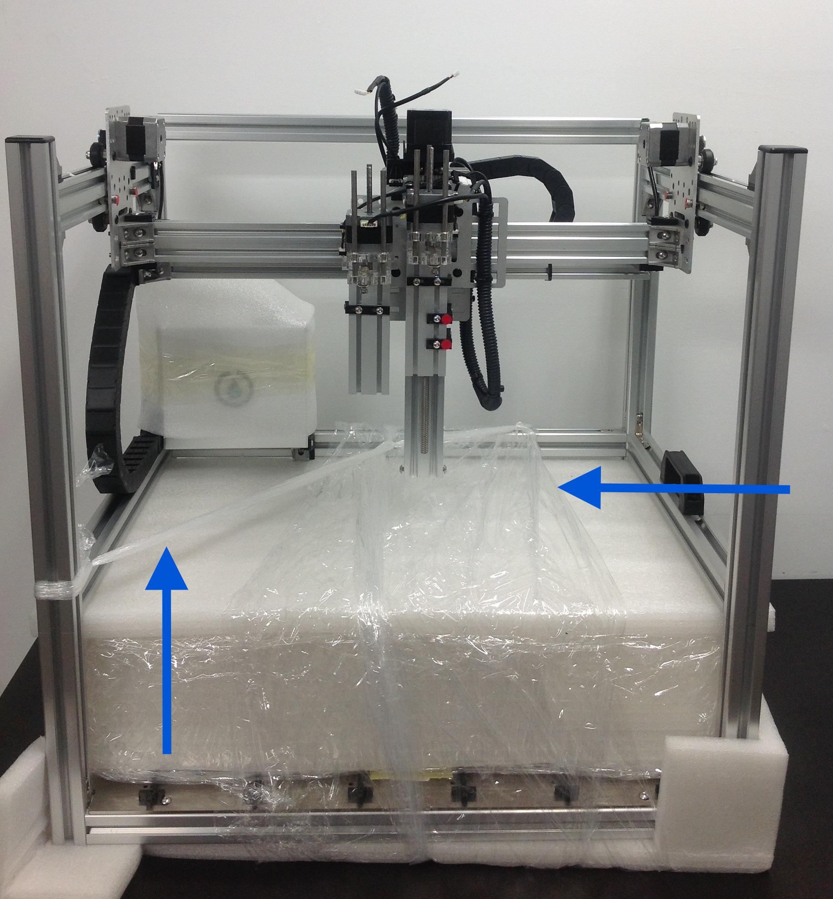

________________________________________________________

Remove the foam box with accessories

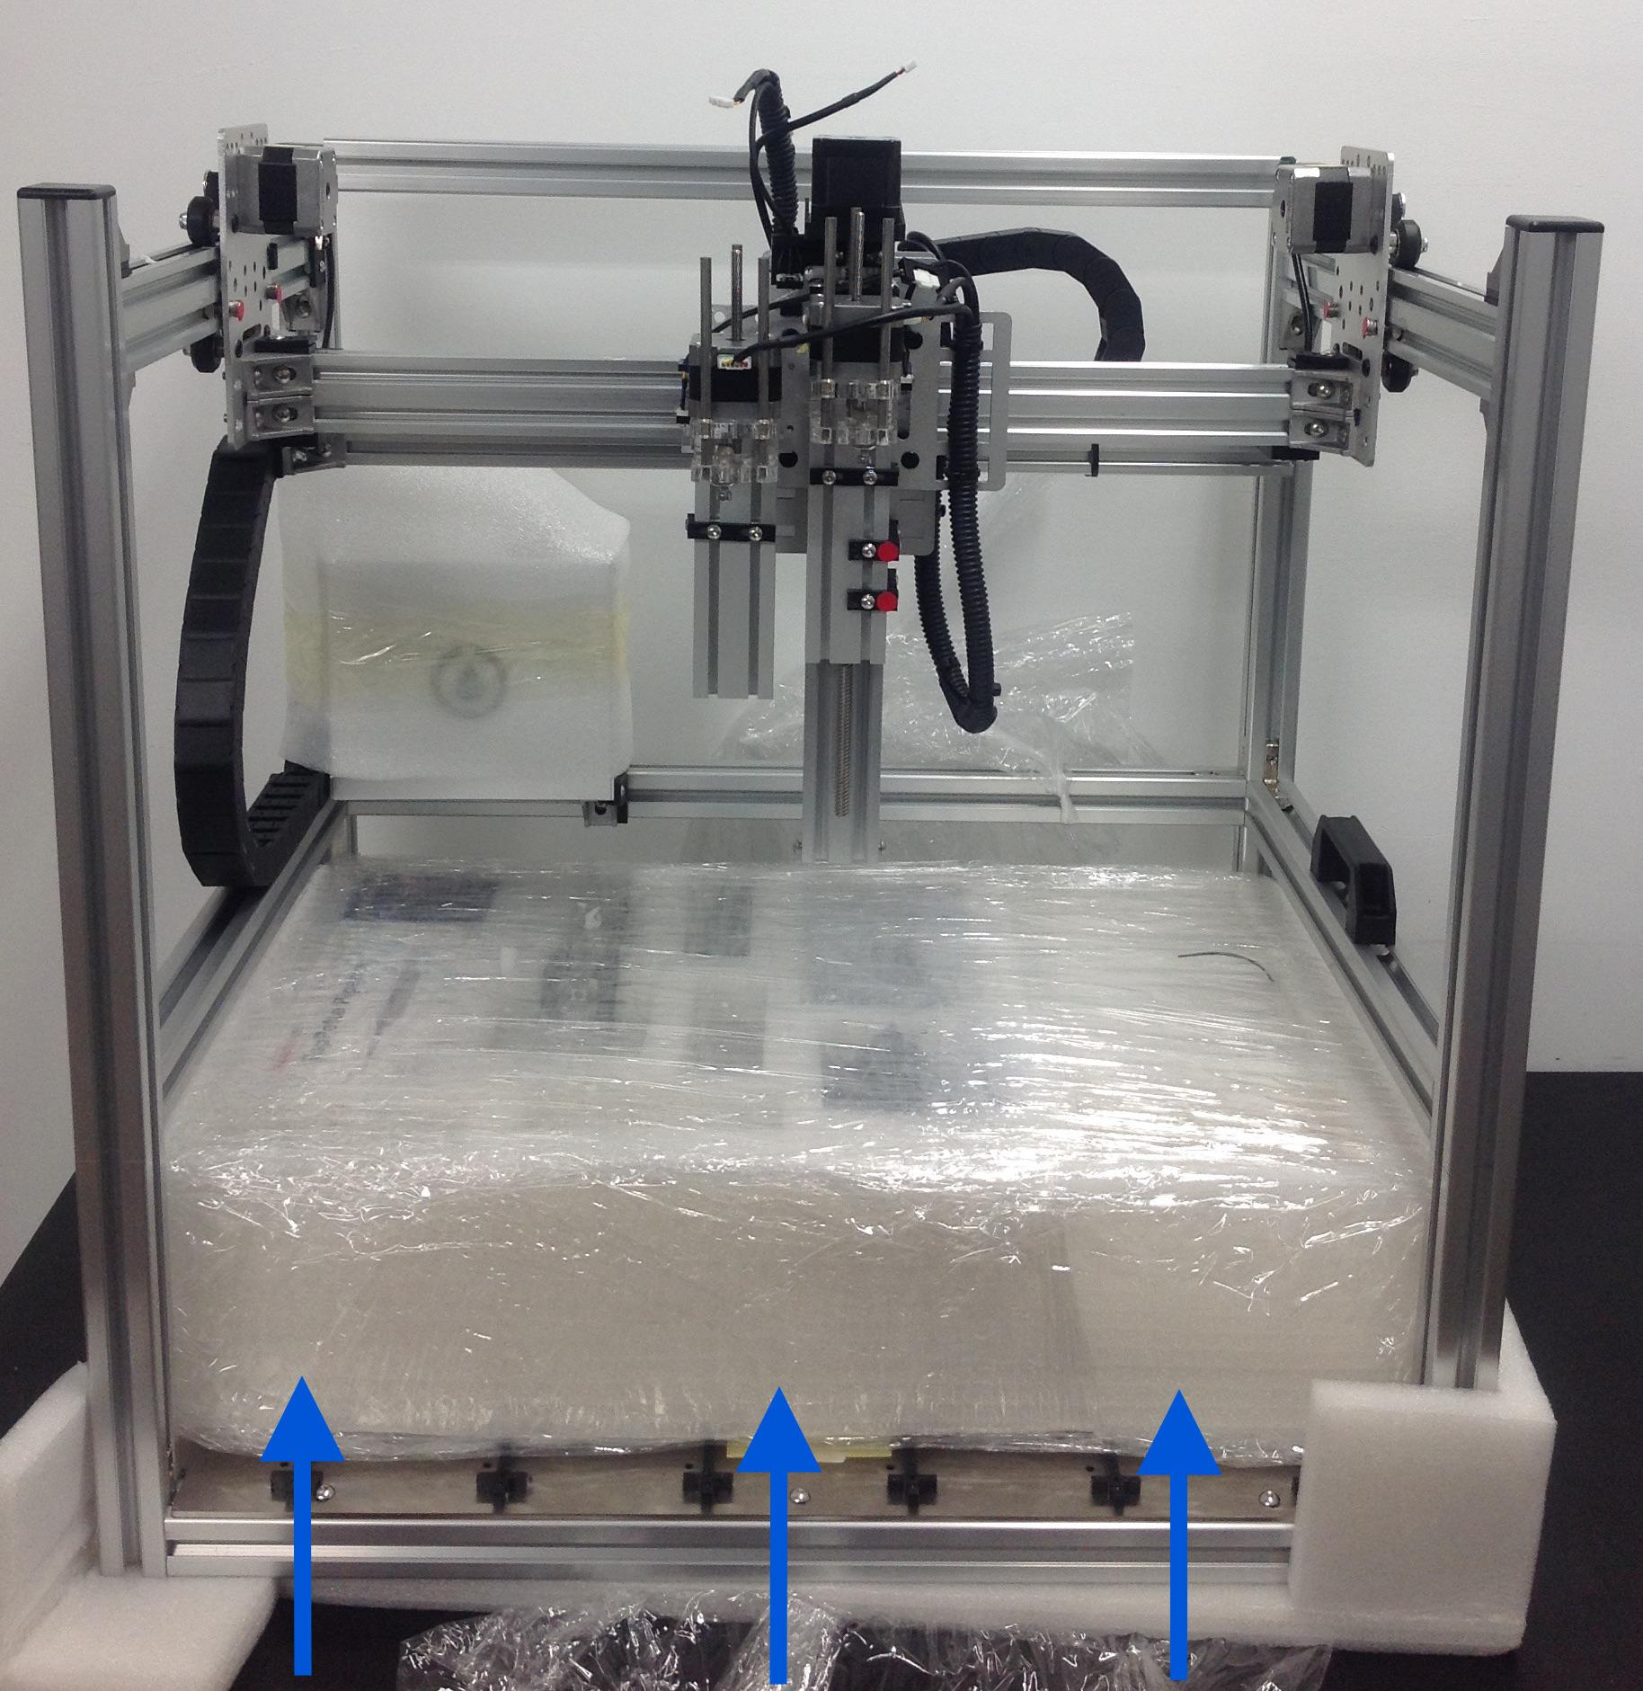

________________________________________________________

Remove foam around the motor controller box and bottom corner foam

